RC tutorial 005 - Alignment with cant (superelevation). The Alignment Coordinate System.

===============================================================================

Revised 2019-09-30

* This tutorial's goal is to teach you the Alignment Coordinate System concept. There is much to read this time! We also touch on Lua formulas in alignments.
* Assumed RailCOMPLETE skills: Previous lessons.
* Assumed railway skills: You know about railway geometry, vertical profile, cant (superelevation), and right-handed coordinate systems.
* Time to spend here: Intermediate: 1 hour. Beginner: 2-3 hours.
* Notice to users with non-English versions of AutoCAD – see footnote[1].
* This tutorial was prepared using software release 2018.22.1284 with Norwegian DNA version “2019.1 gamma”,” NO-BN;NO-0001;2019-10-01T06:45:00+01:00;2019.1”.
* Note: If you are using AutoCAD version 2017 or older, then open the 2013-format version of the tutorial DWG file.

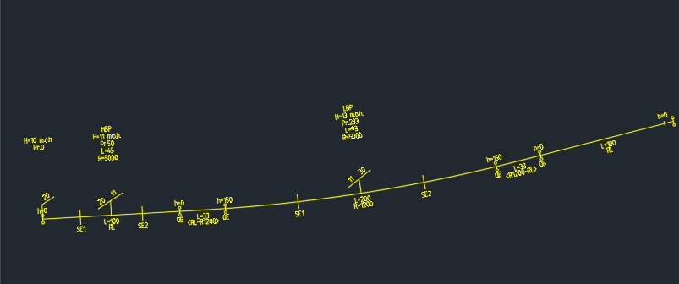

1. Start AutoCAD with RailCOMPLETE, then open the ‘General Tutorials’ folder and locate the DWG file named after this tutorial. You can either type RC-ShowGeneralTutorials or you can locate the button below the RC logo in the upper left corner of your AutoCAD window.
2. The RailCOMPLETE definitions for the Bane NOR network assets measure most lengths in meters and use decimal degrees for presenting angular measures. Cant (superelevation) is measured in millimeters, according to the LandXML 1.2 definitions for metric projects.

NOTE: Some alignment design packages express cant in meters or other units. You may have to scale cant upon importing or exporting alignments with cant data.

1. Your CAD editor is assumed to operate in a Cartesian XYZ World Coordinate System (WCS) set to meter [m] unit for each axis. To express your object's coordinates in another Cartesian X'Y'Z' user coordinate system (UCS), use AutoCAD command UCS to set the new origo and axis directions, then use PLAN or EXPLAN to rotate your view so the X' axis points straight right on your screen. To view objects from other angles you may rotate your CAD view. Hold down the Shift key while pressing the mouse scrollwheel down and moving your mouse. However, the RailCOMPLETE Property Manager always shows geoCoord XYZ as WCS coordinates.
2. With RailCOMPLETE we speak about ‘Alignment Coordinate System’ (ACS). This is to be interpreted as a Cartesian (orthogonal) axis system which 'slides' along a specific alignment in 3D, in the direction of increasing mileage.   
     
   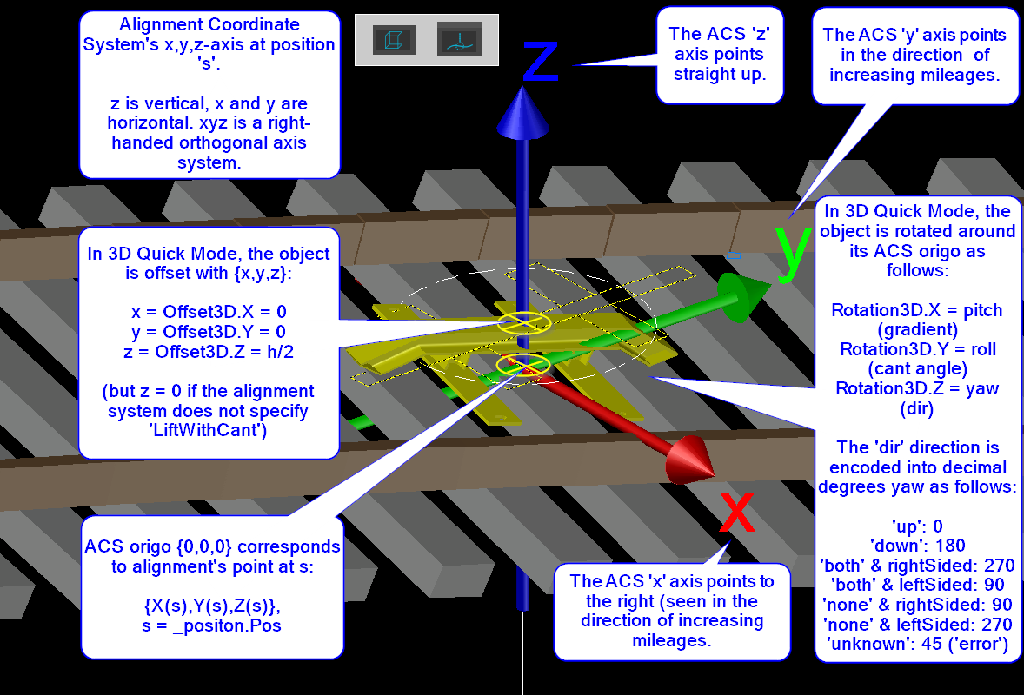  
     
   Let ‘s’ be a positive number ranging from 0 at the start of an alignment’s 2D geometry and ending at ‘Length2D’ at the high-mileage end of that alignment. For each value of s, there is an associated 3D point {X(s),Y(s),Z(s)} belonging to the alignments so-called ‘Alignment Axis’. The ACS’ origo (x,y,z) = {0,0,0} is located at position {X(s),Y(s),Z(s)}, called ‘_position’ in Lua[2], and oriented such that the local ACS y-axis is colinear with the local geometry tangent direction, which is always a vector in the WCS (World Coordinate System) XY plane, and pointing in the direction of increasing positions (increasing mileage). The local ACS z-axis is always colinear with the WCS Z-axis, i.e. pointing 'straight up in the air'. The ACS x-axis is oriented orthogonally to the y- and z- axes, forming a right-handed orthogonal axis system.
3. *Hint*: Imagine that "y" is your right-hand index finger which is pointing along the alignment in the increasing mileage direction, and "z" is your right-hand middle finger pointing straight up. Then "x" is your right-hand thumb, pointing to the right side of the alignment.
4. '_position.Pos' is a continuous and strictly increasing distance measure along the alignment's 2D centre line, whereas the 'Mileage' is a piecewise linear mapping from this position to "railway position name" of that position - called "mileage" (German: Kilometrierung, French: Point kilometrique ("peh-kah")). The mileage mapping function is often called "chaining". The discontinuities in mileage are often called "chain breaks". With Bane NOR, the mileage is always increasing in the direction leading away from Oslo Central Station. Some administrations use continuous chaining as far as possible, whereas others (e.g. Trafikverket in Sweden, SNCF Réseau in France) use mileage posts with a chain break at every kilometer of line or so. In the latter situation, railway positions (mileage, chaining) is often expressed as "xxx+yyyy" where xxx=previous mile post's integer kilometer value, and yyyy=offset in meters from the previous mile post. yyyy values are typically found between 900 to 1100 meters. With Bane NOR, mileage is expressed in drawings as either "xxx,yyy" where xxx=kilometers and yyy=meters from the zero mileage position, or sometimes "xxx,yyyyyy" when millimeter precision is needed.
5. In the RailCOMPLETE Property Manager, Object Manager and Alignment Manager, basic mileage values are expressed in meters (not kilometers).
6. Superelevation (cant) with most railway administrations (such as Bane NOR) is measured as a vertical uplift of one top-of-rail in relation to the other, expressed in milllimeters [mm]. Cant is basically a signed angle expressing a sleeper’s rotation about the local alignment axis (roll) using the horizontal XY plane as a reference.
7. For historical and for practical reasons, cant is rather measured and logged using a water level device and reading the vertical distance between the two top-of-rails. According to the Permanent Way blog webpages (pwayblog), there is a standard reference ‘cant gauge’ associated with each track gauge, for conversion of cant between millimeters and angle. For normal gauge tracks (1432..1438 mm between the two wheel/rail contact points), the standardized cant gauge reference value is 1.5 m. That is, sin(alpha) = h/1500 for normal gauge tracks, where h = cant in millimeters and alpha is the cant angle. The sign of the cant angle is also subject to interpretation. Most track design software packages interpret ‘clockwise cant rotation’ as a positive rotation about the ACS y-axis. Wider gauges use 1600 mm or more as a cant gauge track reference, see the literature on this.
8. Select the alignment again and look for the Alignment tab and the Alignment System row in the Properties Manager. It should read “Normalspor 1435 mm”, which is the standard for mainlines in Norway. Click to the left of that row to expand it, and you will see the rows ‘Cant Gauge’ (1.5 meters) and ‘Alignment Gauge’ (1.435 meters). The CantGauge value is used when converting cant between millimeters and angles[3]. The AlignmentGauge is used when placing e.g. axle counters or track joint isolations etc in rails, or when expressing the rail/wheel contact lines in 3D. Think of it – as cant increases, the two rails in a railway track alignment will “creep inwards” towards the alignment axis (as seen from above), without moving the track sideways.  
     
   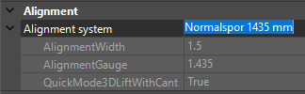
9. Various alignment systems are defined in the DNA. Speak to your local RC agent if you miss one. Some of alignment systems – platform edges, for instance – have 0 as CantGauge. This instructs RailCOMPLETE to interpret the Cant value as a signed Decimal Degrees angle.
10. The last row in the alignment system, QuickMode3DLiftWithCant, is used by RailCOMPLETE when converting an alignment object into 3D graphics. Some administrations interpret the cant as a mere rotation about the alignment axis, but most administrations interpret the cant as a rotation and an upwards translation by half the cant in millimeters. The result is that the lowest rail is always level with the alignment axis Z(s)-value.
11. If an alignment is expressed in 3D with its QuickMode3D set to ‘true’, then RailCOMPLETE considers that the sleepers shall be lifted with half the cant if the alignment’s Alignment System definition says so. In other words, the 3D Offset Z (‘Offset3D.Z’ in Lua) is implicitly replaced by the formula “getAlignmentInfo(_position).Cant/2”, no matter what formula you might have stored for Offset3D.Z yourself.  
      
    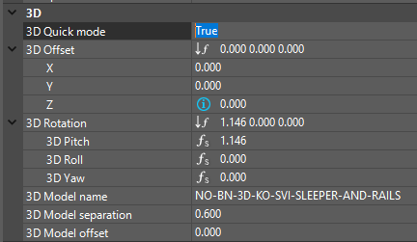
12. When an alignment’s QuickMode3D is set to true, then the Offset3D.X and Offset3D.Y are implicitly set to zero, no matter what formulas you might have stored in them yourself.
13. When an alignment’s QuickMode3D is set to true, then the Rotation3D.X, Rotation3D.Y and Rotation3D.Z formulas are implicitly set to express the rotations you would expect for an object which is installed in a track, such as a sleeper being repeated for every 60 cm or so.
14. In the tutorial DWG file, you will find these values / formulas for the alignment, being used when Quick Mode is false. The ‘NOBN_...’ formulas are stored in the DNA for NO-BN (Bane NOR):  
      
    Offset3D.X 0  
    Offset3D.Y 0  
    Offset3D.Z **NOBN_trk_getLiftFromCant**(_position)  
    Rotation3D.X (pitch) **NOBN_trk_getPitchFromGradient**(_position)  
    Rotation3D.Y (roll) **NOBN_trk_getRollFromCant**(_position)  
    Rotation3D.Z (yaw) 0
15. Activate the RC-Show3DPreview tool  and select the alignment. Play a little with QuickMode3D turned on or off, with values or formulas that you assign yourself to the Offset3D. Place your cursor in the row of interest and press F3 to bring up the Lua editor.
16. When cant is applied to an object, be it a top-of-rail line, a balise, an axle counter, a switch or any other track-bound object, then we rotate the object's lateral position (x,z) around the local ACS y-axis and then translate it upwards by half the superelevation. In this way, both rails will be slightly moved inwards, and the lowest rail's top-of-rail will remain at the alignment's elevation at that position (i.e. at relative elevation zero). Viewed from the positive Z-axis, adding cant to an alignment this way does not change the geometry. If you had instead rotated a track around the lowest rail's top-of-rail, or lowest wheel-rail-contact-point, then the other rail and the centre line would have moved sideways towards the lower rail, which would lead to an unwanted change in alignment geometry.
17. Play a little around with the various alignment annotation tools: RC-ShowAlignmentGeometry, RC-ShowAlignmentProfile, RC-ShowAlignmentMileage, RC-ShowAlignmentName, RC-ShowTwoRails.
18. Copy your track annotations to drawing before you start changing too much. Activate the alignment annotation tools, select the alignment, right-click and select "RailCOMPLETE Annotations => Copy Annotations to Drawing".
19. NOTE: AutoCAD might hide away such annotations from time to time. Using the AutoCAD command AUDIT / _Yes will usually fix this problem, even if AutoCAD reports "Total errors found 0 fixed 0.".
20. Start the Alignment Manager and select the alignment "T01". Check the "Bind to Selection" box.
21. Activate the Alignment / Cant tab. You will see a datagrid displaying the cant details of your alignment.
22. As mentioned above, LandXML and AutoCAD Civil 3D talk about "clockwise cant rotation" and "counterclockwise cant rotation". The mental reference is a 2D profile cut-through of your railway system, a drawing showing the inclined sleepers and tracks with surrounding banks, seen in the direction of increasing mileage. If you think of a superimposed clock's arrows, then lowering the right bank corresponds to increasing time (CW rotation) and vice versa. This is how also RailCOMPLETE interprets cant rotation in LandXML files.
23. NOTE: There is no required definition of CW / CCW reference system in the LandXML 1.2 XSD, so you may have to flip CW/CCW upon import or export of LandXML files to get things right. Or simply set the Cant Scale to ‘-1’ when using RC-ImportAlignmentsFromLandXml.  
    
24. NOTE: If we consider an object rotated with its alignment's cant rotation, expressed in the local Alignment Coordinate System (ACS), then a positive rotation about the local y-axis (which points in the direction of increasing mileage) will raise the left side above the right side, as viewed in the direction of increasing mileage.
25. Check the "Enable Edit" box to allow for modifications in the datagrid.
26. To visualize cant in 3D, you will need to express your railway track using sleepers and rails. Start the RC-Export3D command from the ribbon (under the Import/Export button), and navigate to the ‘Point Objects’ tab. Verify that the references to 3D object libraries are OK (no warning triangles). Deleting all paths (the ‘-‘ minus to the right) will trigger a reset of paths to the current DNA’s settings.  
      
      
    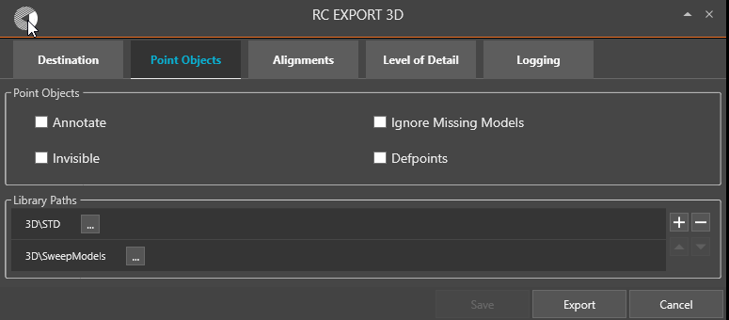
27. Use the ‘Destination’ tab to specify where you want your results to appear. In the ‘Alignments’ tab you may choose to add the alignment axis {X(s),Y(s),Z(s)} and / or the Model Insertion Axis.
28. Select the alignment, locate the ‘Model3DName’ property, Specify one of the standard sleeper & rail object models from the standard 3D library, for instance the object model ‘NO-BN-3D-KO-SVI-SLEEPER-AND-RAILS’. It contains one sleeper and two 60 cm pieces of rail, i.e. a not-so-detailed visualization.
29. Locate ‘Model3DSeparation’ property and verify that it is set to 0.6 meters. This will result in a 60 cm “jump” from one sleeper insertion to the next.  
    Note: The 3D model separation jumps are measured along the 3D alignment axis and not along the XY-plane geometry 2DLength. A track with much up and down will need more sleepers than a flat track. Press the "Export" button to start expressing your BIM alignment as 3D.
30. The last 3D property is ‘Model3DOffset’. It allows you to start at a specified position in the alignment’s XY-plane geometry, i.e. a start value for ‘s’. It should be between 0 and Length2D. In Lua formulas, the Length2D can be accessed from an alignment as ‘RcAlignment.HorizontalProfile.Length’. Set it to half of Model3DSeparation if your 3D object model has its insertion point in the middle. Try to play with different values – see the resulting 3D representation.
31. Each time you have made changes to cant you may visualize them in 3D by selecting the alignment, right-clicking and selecting "RailCOMPLETE Export 3D" (command RC-Export3DUsingCurrentConfig). Your current settings from the RC-Export3D will be used. Alternatively, activate the RC-Show3DPreview tool (which will always return its results to layer 0 in your drawing).
32. Experiment in Alignment Manager with various settings for cant position, can value and rotation. Select and delete your previous 3D exports if you don't want a messy model. For instance, check the effect of using exaggerated cant values and reversing cant rotation directions. The usual maximum cant for railway tracks is around 150 mm. Setting it to 500 mm results in a track with 30 degrees cant.

Please check our website www.railcomplete.com for updates.

Corrections and suggestions are welcome to' support@railcomplete.no.

Thank you for using RC Tutorials!

1. Your AutoCAD session has probably been started from a Windows shortcut of the type:  
   “C:\Program Files\Autodesk\AutoCAD 2019\acad.exe” /product ACAD /language “fr-FR”  
   (“fr-FR” means “French language, France’s version) similar. Native AutoCAD commands may have different names in your language pack, other than the COPY, COPYBASE, FIND etc that you see in our tutorial texts. In order to instruct AutoCAD to accept the native English command name, precede the native (English) command name by an underscore character, ‘_’. For instance: ‘_FIND’ will start AutoCAD’s native ‘FIND’ command even if you are using AutoCAD with the French language pack, where the command in French is called ‘RECHERCHER’.If a command needs an argument ‘ON’, and the French menu says ‘Allumer’, then you can enter ‘_ON’ to instruct AutoCAD to use the option’s native name.
2. *_position* is actually a data structure with two attributes: *_position.Ref* holds a RailCOMPLETE reference to an alignment object, and *_position.Pos* is the distance travelled in meters from the start of that alignment.
3. In RailCOMPLETE, an AlignmentSystem may have a CantGauge which is zero. If CantGauge is zero, then the Cant value found in the alignment is interpreted as rotation angle in Decimal Degrees.